**Step 01: Enable WSL in Windows**

To enable the WSL feature in Windows Operating system. Follow the steps below:

1. Search **Command Prompt**, **left-click** on the mouse, and select “**Run as administrator**” to open it as administrator.

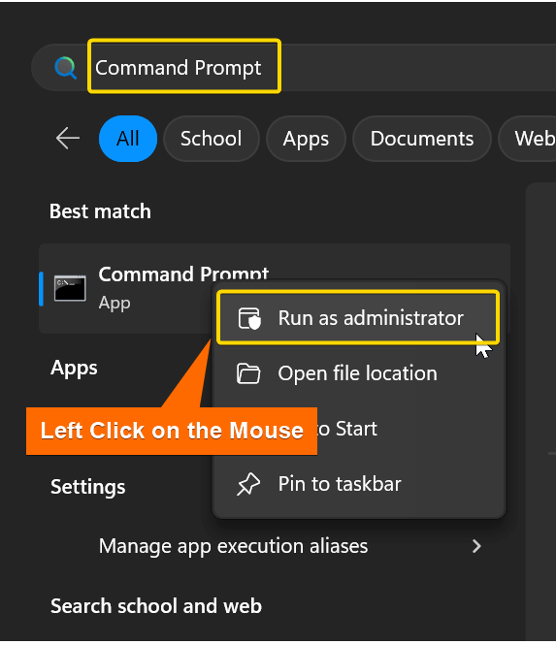

2.To **enable WSL**, insert the following command and hit **ENTER**:

**dism.exe /online /enable-feature /featurename:Microsoft-Windows-Subsystem-Linux /all /norestart**

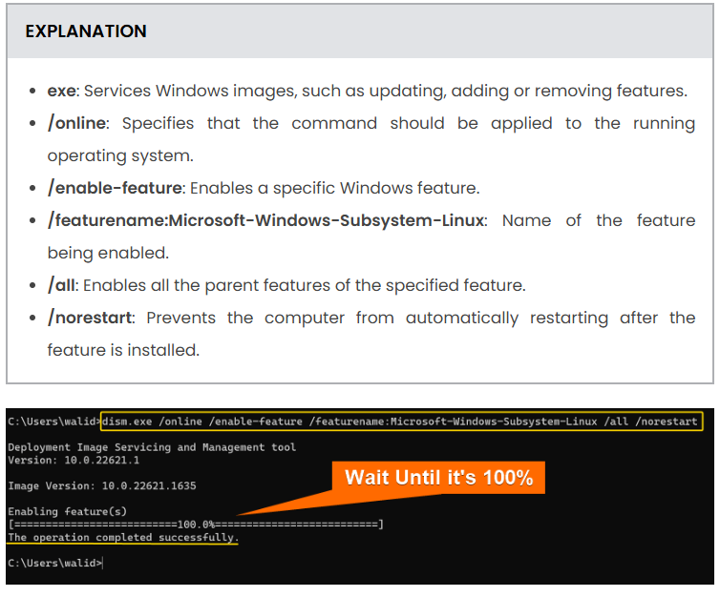

Wait for **100**% and the “**The operation completed successfully**” message at the end.

3.Again, to **enable Virtual Machine Platform**, insert the following command and hit **ENTER**:

**dism.exe /online /enable-feature /featurename:VirtualMachinePlatform /all /norestart**

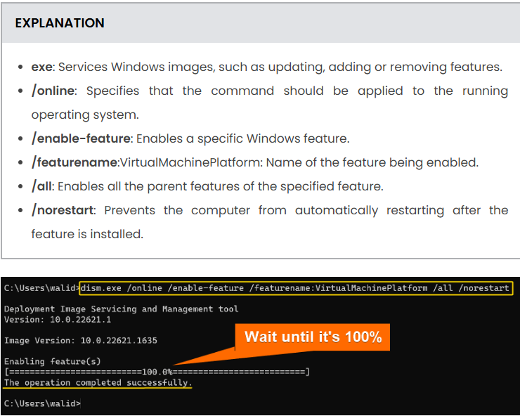

Like the previous, you will see **100%** and the “**The operation completed successfully**” message. This process will enable the **Virtual Machine Platform** feature which allows users to run virtual machines natively on Windows.

4.Important step: Then **restart** the computer.

**Step 02: Make WSL 2 Default**

To make **WSL 2** the default WSL version, which means Linux distros will be installed on WSL 2 by default:

1. To make WSL 2 default, write the following command in the **Command Prompt**:

**wsl --set-default-version 2**

**EXPLANATION**

* **wsl**: Manages WSL.
* **–set-default-version**: Sets default WSL version.
* **2**: The WSL version number.

**2.**Press **ENTER**from the keyboard

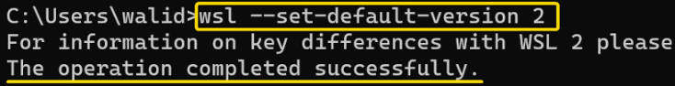

You should see an output like the above.

**Step 03: Install Ubuntu in WSL 2**

Finally, install **Ubuntu**in **WSL**. You can do the same by following the steps below:

1.At first, use the following command to **list**all the available **Linux distros**

**wsl --list –online**

**EXPLANATION**

* **wsl**: Manages WSL.
* **–list**: Lists installed or available distros.
* **–online**: Lists only those distros which can be downloaded online.

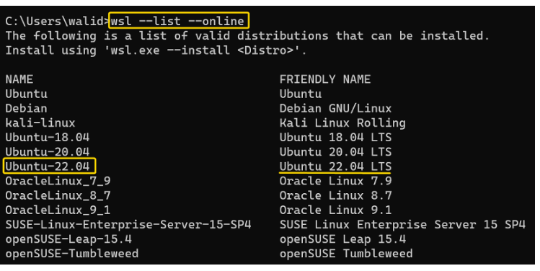

You will see **two**columns, the **name**of the Linux distro and its corresponding **friendly name**. Iill install “**Ubuntu-22.04**” in the next step.

2.To install **Ubuntu**, copy the following command:

**wsl --install -d Ubuntu-22.04**

**or**

**latest version available**

**EXPLANATION**

* **wsl**: Manages WSL.
* **–install**: Install a new Linux distro.
* **-d**: Specify that you are installing a distribution.
* **Ubuntu-22.04**: Name of the distro that is being installed.

3.Give a **username**for the Ubuntu.

4.Finally, set a **password**.

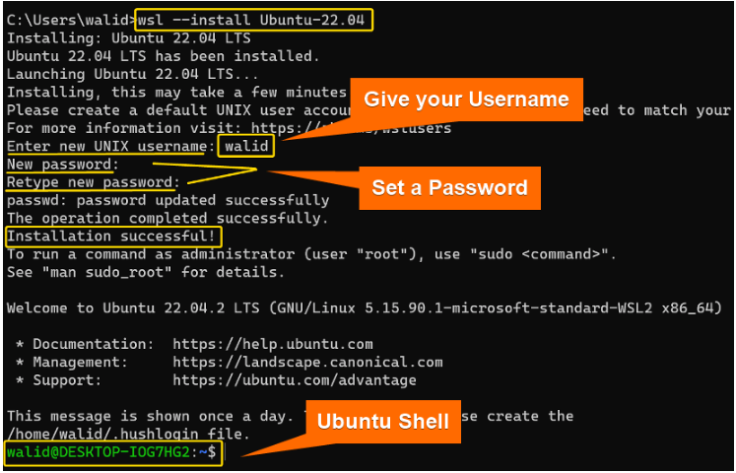

You should remember that this whole process can take some time. In the end, you should see an **Ubuntu shell** where you can execute Linux commands.

**Warning**: If you face any issue while installing Linux distribution, check the WSL status using:

**wsl --status**

If, this happens due to the WSL kernel being missing then run:

**wsl --update**

This should solve the issue.

5.Now you should find Ubuntu in your Windows like below:

